Autonomous On-Board Sequence Validation and Orientation-Agnostic Human Activity Recognition for Microgravity Payloads on the Bharatiya Antariksh Station

Abstract
Long-duration space habitation and the normalized operations of modular orbital laboratories, such as the upcoming Bharatiya Antariksh Station (BAS) [cite: 15, 120], represent a major shift from short-duration technology demonstrations to sustained, multi-disciplinary scientific research in Low Earth Orbit (LEO) [cite: 15, 139]. However, conducting complex physical experiments in orbit is severely constrained by communication latencies, limited ground visibility windows, and strict bandwidth limits that prevent high-definition video feeds from being streamed back to Earth [cite: 121].

To secure the integrity of scientific procedures without depending on continuous ground support, this thesis presents a complete, edge-deployed, offline AI assistant designed for on-board Human Activity Recognition (HAR) and sequence validation [cite: 121, 122]. The system processes video streams locally from fixed-payload cameras [cite: 237], tracks astronaut movements, validates hand-object interactions [cite: 125, 126], checks procedural sequence compliance using a deterministic Finite State Machine (FSM) [cite: 131, 132], and provides interactive hands-free Text-to-Speech (TTS) guidance and alerts [cite: 131, 132, 154].

To overcome the biomechanical, postural, and rotational shifts of weightlessness—where standard terrestrial 2D and 3D posture models fail because astronauts adopt a relaxed Neutral Body Posture (NBP 0G) [cite: 40, 145] and operate in arbitrary, inverted orientations [cite: 127, 178]—the visual pipeline utilizes an Orientation-Agnostic 3D Human Mesh Recovery (HMR) framework [cite: 127, 128]. By applying a Canonical Orientation Constraint (COC) [cite: 149, 182] and projecting camera-space coordinates into a fixed Payload-Rack coordinate frame ($\mathcal{R}$) [cite: 129], we decouple tracking from the astronaut's floating body angle [cite: 129, 187].

The visual model is optimized using PhysAstro-Pose, a semi-supervised Mean Teacher architecture [cite: 148, 194] that incorporates a Structure-aware Pseudo-Label Refinement (S-PLR) module [cite: 149, 182] and an Uncertainty-guided Rotational Consistency Framework (URCF) [cite: 149, 183], achieving a major leap on the target-domain Astro-Pose dataset [cite: 192, 196].

Finally, the visual tracking outputs are integrated into a multi-agent orchestration layer [cite: 36] running on spaceflight processors—specifically the NASA/Microchip PIC64-HPSC [cite: 151, 161] and conduction-cooled NVIDIA Jetson Orin NX platforms [cite: 70, 123]—enabling local real-time streaming, interactive Qt GUI monitoring [cite: 133, 135], and compressing uncompressed video data into timestamped JSON Lines telemetry at a 3,000,000:1 compression ratio [cite: 122, 166]. This standalone AI system is positioned as a foundational technology for next-generation orbital laboratories [cite: 136, 171].

Chapter 1: Introduction and Strategic Background

1.1 Manned Spaceflight Evolution: The Bharatiya Antariksh Station (BAS)
Human spaceflight is transitioning from short, isolated orbital missions to sustained long-duration human presence in Low Earth Orbit (LEO) [cite: 12, 139]. Under the Amrit Kaal Vision 2047 and the expanded Gaganyaan Programme [cite: 20, 211], the Indian Space Research Organisation (ISRO) is executing a phased development roadmap to establish the Bharatiya Antariksh Station (BAS) [cite: 19, 212]. The program envisions the launch of its first base module (BAS-01) by December 2028 aboard an LVM3 heavy-lift launch vehicle, with the full five-module assembly reaching an operational, permanently crewed status by 2035 [cite: 19, 23, 28].
The modular, 52-tonne station will orbit Earth in a stable circular trajectory at an altitude of approximately 400 to 450 kilometers with an inclination of 51.5° [cite: 141]. The station's architecture is composed of five specialized modules [cite: 22, 31]:
- BAS-01 (Base Module): Houses primary crew quarters, environmental control and life support systems (ECLSS), and docking interfaces [cite: 22, 31].
- BAS-02 (Core Module): Manages structural stability, station control, and internal systems integration [cite: 22, 31].
- BAS-03 (Science Research Module): Dedicated entirely to microgravity research in biotechnology, physical sciences, and human physiology [cite: 22, 31].
- BAS-04 (Laboratory Module): Designed to host extended experimental racks, technology demonstrations, and long-term space studies [cite: 22, 31].
- BAS-05 (Common Berthing Module): Facilitates logistics, cargo docking, external maintenance, and structural expansion [cite: 22, 31].

1.2 The Bottleneck of Deep-Space Communications
Conducting highly precise scientific experiments inside the BAS-03 and BAS-04 modules places a heavy cognitive and physical workload on the crew [cite: 121, 176]. Historically, space missions have relied on constant, real-time audio and video communications with ground-based Principal Investigators and mission control teams to ensure compliance with experimental protocols [cite: 121]. However, in LEO operations, this model is fundamentally constrained by:
- Bandwidth Allocations: High-definition video streams require substantial telemetry bandwidth, which is frequently bottlenecked by the station's narrow S-band and Ka-band transmitter limits [cite: 121, 211].
- Signal Propagation Delays: Brief delays in routing signals through tracking and data relay satellite systems (TDRSS) hinder instantaneous ground-based feedback.
- Orbital Pass Outages: The station experiences frequent periods of ground-station loss-of-signal (LOS) during specific orbital phases, cutting off real-time external support [cite: 121].

1.3 On-Board Computational Assistance: System Requirements
To maintain the integrity of space science without depending on continuous ground telemetry, the station requires an intelligent, on-board, offline assistant powered by Human Activity Recognition (HAR) [cite: 121, 122]. This on-board assistant must meet the following operational criteria:
- Fully Offline Operation: The system must run entirely on the station's local edge processors, demanding zero external internet or cloud connectivity [cite: 237].
- Hands-Free Interactive Guidance: The system must provide voice-based instructions and alerts, allowing astronauts to keep their eyes and hands focused on delicate materials [cite: 131, 132, 153].
- High-Ratio Data Compression: Rather than saving massive gigabytes of raw video files, the system must compress raw payload video into highly compact, structured text-based logs of procedural states [cite: 121, 122].

Chapter 2: Postural and Kinematic Physics of Microgravity

Traditional Human Activity Recognition (HAR) models and skeleton-based 3D posture trackers are built upon terrestrial biomechanical assumptions [cite: 62, 145]. Translating these systems directly into a free-fall orbital environment triggers immediate structural failures [cite: 62, 178].

2.1 Musculoskeletal Unloading and Neutral Body Posture (NBP 0G)
In 1G terrestrial conditions, human postural control strategies are constantly acting against the downward force of gravity [cite: 145]. The nervous system regulates muscle activations to maintain an upright or seated posture relative to a flat floor [cite: 145, 178]. In microgravity, this gravitational loading is removed, and the musculoskeletal system unloads [cite: 145, 177].

When relaxed, the body naturally adopts the Neutral Body Posture (NBP 0G), which was first characterized during long-duration flights aboard the Russian Mir space station and the ISS [cite: 40, 145]:

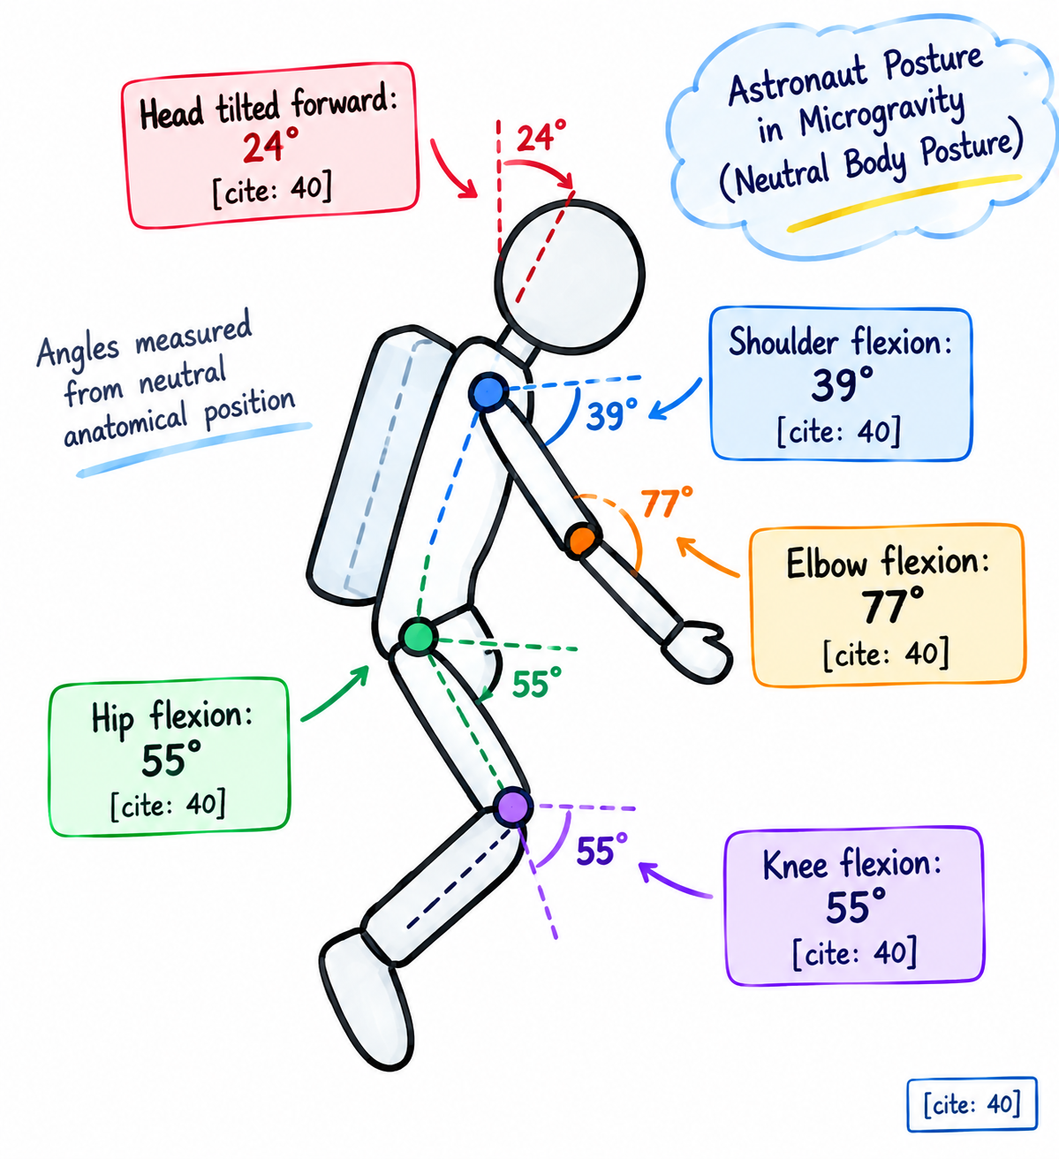
Biomechanical kinematic evaluations show that compared to standard terrestrial standing, the NBP 0G introduces specific joint-angle shifts [cite: 40]:
- Cervical Spine: Neck flexion increases by approximately 24°, with a corresponding 15° reduction in the operator's line of sight [cite: 40].
- Upper Limbs: Shoulder joints naturally flex to 39° and abduct to 35°, while the elbow joints flex to approximately 77° with 60° of pronation [cite: 40].
- Lower Limbs: Hip joints flex to 55° with 16° of abduction, knee joints flex to 55°, and ankles undergo 21° of plantarflexion [cite: 40].

These severe postural shifts depart completely from the "upright-standing" and "flat-seated" templates that dominate terrestrial training benchmarks like COCO or Kinetics, causing standard posture networks to experience severe keypoint drift and structural deformities [cite: 62, 178].

2.2 Rotational Ambiguity and "No Up or Down" Orientation
The most critical challenge of visual on-board tracking is the absence of a fixed gravity-aligned vertical axis [cite: 127, 184]. In terrestrial environments, the human body is statistically captured in a vertically aligned state [cite: 178]. General-purpose pose estimators (such as OpenPose or ViTPose) learn an implicit upright-body prior from this statistical bias [cite: 178].

In a weightless cabin, astronauts operate in arbitrary orientations: floating horizontally, rotating diagonally, or working completely inverted (upside down) relative to the payload camera [cite: 127, 178]. When an Earth-trained model encounters an inverted floating astronaut, it struggles to resolve the visual features:
- It frequently confuses left and right symmetric limbs (e.g., classifying a floating left hand as a right hand) [cite: 178, 179].
- It misinterprets global body rotation as extreme local joint deformation, leading to distorted skeletal predictions [cite: 178, 179].
- Under self-occlusions, it fails to maintain tracking stability because the spatial coordinate priors of the joints are completely scrambled [cite: 179, 184].

Chapter 3: Orientation-Agnostic 3D Human Mesh Recovery (HMR)

To achieve robust joint-level tracking under unconstrained omnidirectional movements, the visual pipeline employs an Orientation-Agnostic 3D Human Mesh Recovery (HMR) framework [cite: 127, 128].

[ Input Camera Frame ] ──> [ ResNet Backbone ] ──> [ Canonical Orientation Constraint ]
│
▼ [Orientation-Invariant Features]
[ Payload Coordinate Frame (PR) ] <── [ Transformation Matrix ] <── [ Camera-Space Joint Vectors (XC) ]

3.1 Camera-Space Metric Depth Reconstruction
The monocular payload camera outputs raw RGB frames to a multiscale feature extractor [cite: 133, 194]. To reconstruct the astronaut's body structure in metric 3D space, the HMR model predicts joint keypoints in 2D and estimates their corresponding metric depth in log-space [cite: 128]. By incorporating the camera's intrinsic parameter matrix ($K$), the system projects each joint coordinate into a camera-space 3D coordinate vector ($P$) [cite: 128]:

$$P = d ⋅ K^{-1}$$

where:
- $[u, v, 1]^{T}$ represents the projected 2D joint pixel coordinates in the image plane [cite: 128].
- $d$ is the predicted metric depth of the joint from the optical center [cite: 128].
- $K$ is the camera calibration intrinsic matrix containing focal lengths ($f_{x}, f_{y}$) and principal points ($c_{x}, c_{y}$).

3.2 Homogeneous Transformation to Payload-Rack Frame ($\mathcal{R}$)
Because the camera itself may be mounted at an angle relative to the workbench, tracking coordinates directly in the camera-space ($X_{mathcal}$) remains sensitive to sensor tilt or panning [cite: 129]. To resolve this, the system maps the estimated camera-space joints ($X_{mathcal}$) into the stationary local coordinate frame of the fixed payload rack ($mathcal$) [cite: 129]. This spatial projection is executed using a homogeneous transformation matrix [cite: 129]:

$$P_{mathcal}=$$

where:
- $R_{mathcal → mathcal}∈ SO(3)$ is a $3 × 3$ rotation matrix mapping the angular offset between the camera lens and the payload rack [cite: 129].
- $t_{mathcal → mathcal}∈ {mathbb}^{3}$ is a 3D translation vector mapping the physical displacement [cite: 129].

Because the camera is rigidly mounted to the payload structure, these transformation parameters are computed once during initial installation and calibration [cite: 129]. This forces the tracker to measure all joint positions, velocities, and hand-object vectors relative to the stationary workbench rather than the floating astronaut's body axis, rendering the tracking fully independent of the astronaut's orientation [cite: 129, 137].

3.3 The PhysAstro-Pose Semi-Supervised Model
To train this 3D tracking pipeline under a extreme scarcity of annotated microgravity training data, we implement PhysAstro-Pose, a semi-supervised Mean Teacher architecture [cite: 148, 194]. The student network is trained using three specialized, physics-inspired regularizations [cite: 148, 149]:

A. Canonical Orientation Constraint (COC)
To resolve the rotational ambiguity caused by floating postures, the COC defines a static reference direction vector in the image plane [cite: 149, 188]:
$$v_{ref}=$$
It constructs a dynamic body-axis vector using the estimated head and hip keypoints from the skeletal keypoint set ($K$) [cite: 149, 188]:
$$v_{body}= k_{hip}- k_{head}$$
The global body orientation angle ($θ_{orient}$) relative to the camera sensor is calculated geometrically [cite: 149, 188]:
$$θ_{orient}= arccos ( \frac{v_{body}⋅ v_{ref}}{|v_{body}|_{2} |v_{ref}|_{2} + ϵ})$$
where $ϵ = 1 × 10^{-6}$ is a stabilization constant [cite: 149]. Minimizing the orientation loss ($L_{coc}$) on labeled samples prevents the feature extractor from confusing global orientation rotations with local joint deformations [cite: 149, 187]:
$$L_{coc}= \frac{1}{N_{l}}\sum_{n=1}^{N_l}{(} θ_{orient, n}^{pred}- θ_{orient, n}^{gt})^{2}$$

B. Structure-Aware Pseudo-Label Refinement (S-PLR)
Unlabeled frames are incorporated into training by passing them through the teacher network to generate initial pseudo-labels [cite: 149, 189]. However, visual occlusions inside the crowded payload cabin introduce severe structural noise [cite: 179, 189].

S-PLR refines these coordinates at the structural level [cite: 149, 182]. The human skeleton is modeled as a topological graph, and a Graph Convolutional Network (GCN) propagates joint features, utilizing hop-based positional encodings derived from shortest-path distances on the skeleton graph [cite: 149]. This GCN is trained on labeled samples to learn a stable biological prior of human skeletal constraints [cite: 149, 189]. On unlabeled frames, it acts as a structural filter, correcting physically impossible joint configurations (such as an elbow bending backwards) before they are passed to supervise the student network [cite: 149, 189].

C. Uncertainty-Guided Rotational Consistency (URCF)
To ensure rotational robustness, unlabeled frames undergo rotational data augmentation [cite: 149, 183]. However, forcing the student to match highly incorrect pseudo-labels on heavily distorted frames can corrupt the model's weights [cite: 190].

URCF calculates the spatial dispersion of the teacher's keypoint heatmap predictions to estimate sample confidence [cite: 149, 190]. Poses with high confidence are assigned strong consistency loss weights ($w_{j}$), while noisy, highly occluded frames are discounted, stabilizing the semi-supervised learning loop [cite: 149, 190].

Chapter 4: Spatiotemporal Activity Spotting and Saliency Gating

Processing full-resolution, high-definition video frames continuously on a spaceflight edge computer is computationally and thermally unsustainable [cite: 123, 151]. The visual pipeline must deploy intelligent gating to minimize computational overhead [cite: 119].

4.1 Custom Synthetic Data Engine
To train the specialized object detection and interaction models, we developed a custom synthetic dataset modeling the target experimental workspace [cite: 124]. The experiment consists of a primary containment box housing a red box and a yellow box [cite: 124].

Using ground-based physical rendering engines (e.g., NVIDIA Isaac Sim), we generated millions of synthetic frames representing the workspace under unconstrained 3D rotations, varying lighting, and simulated camera noise [cite: 124, 125]. This synthetic corpus was mixed with real-world, hand-labeled images captured from a physical mock-up of the experiment bay to bridge the sim-to-real domain gap [cite: 125].

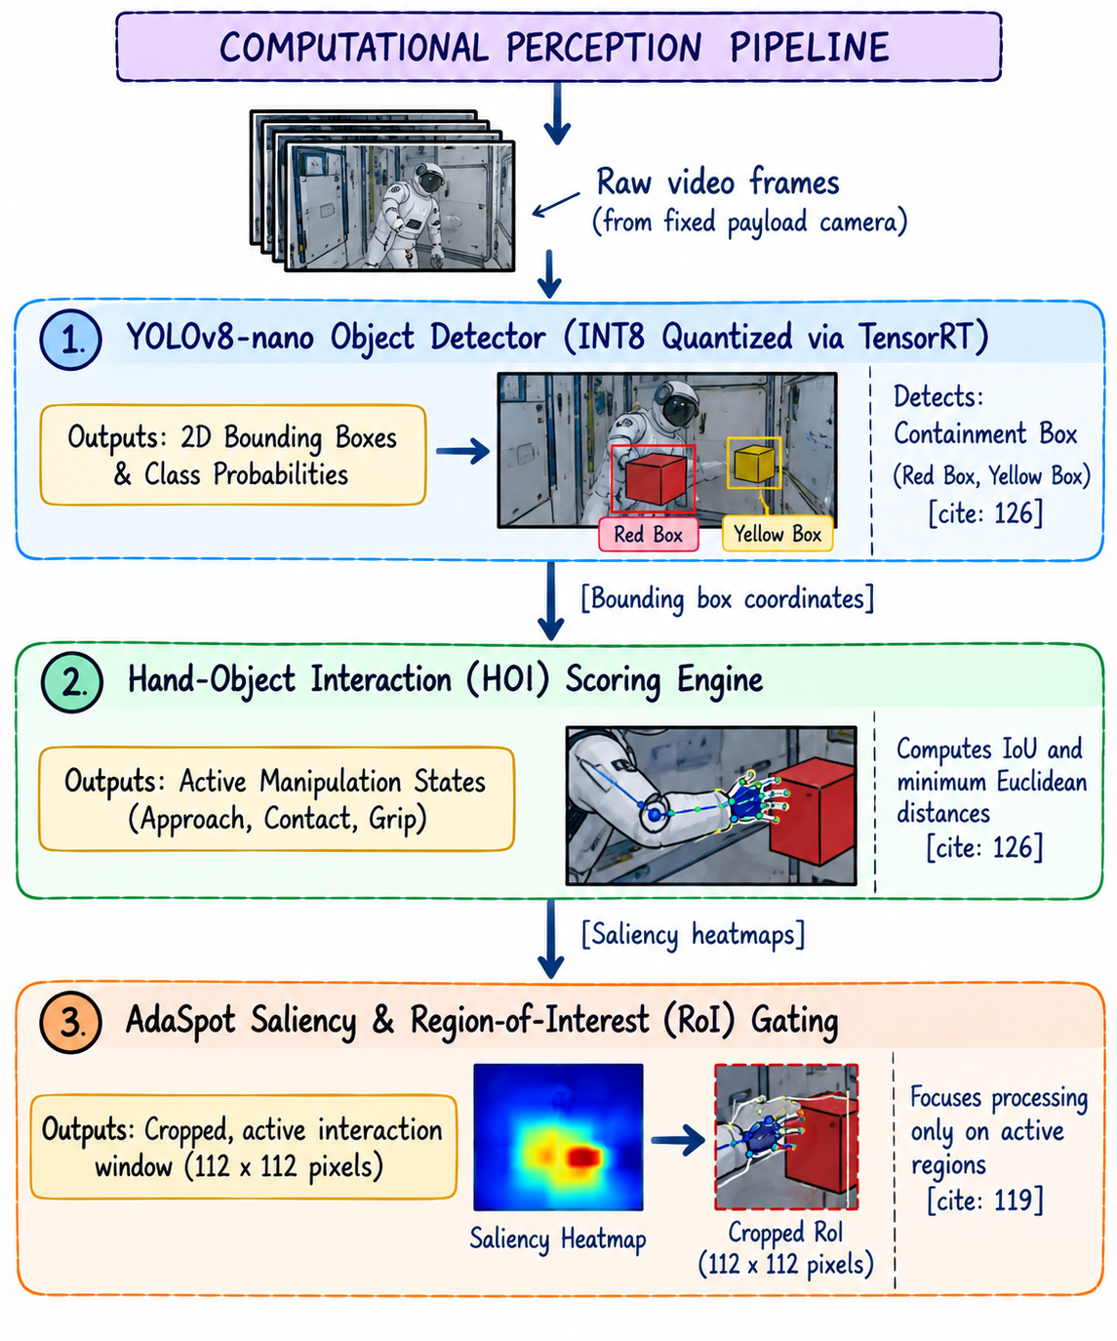

4.2 2D Object Detection and Hand-Object Interaction (HOI)
- Target Detection: A customized YOLOv8-nano network, quantized to INT8 precision using TensorRT, runs local inference to localize the containment box, red box, and yellow box, outputting 2D bounding boxes and class probabilities [cite: 126].
- HOI Scoring: Bounding boxes are routed to the HOI scoring engine [cite: 126]. By computing the intersection-over-union (IoU) and minimum Euclidean distances ($d_{HOI}$) between the astronaut's hand joints (derived from the 3D HMR mesh) and the target boxes, the system detects physical manipulation events [cite: 126]:
$$d_{HOI}= \min_{p ∈ Hand, q ∈ Object}|p - q|_{2}$$
A threshold of $d_{HOI}le 5 cm$ over five consecutive frames validates an active handling state.

4.3 Computational Saliency Gating via AdaSpot
To prevent the 3D HMR and object detection backbones from processing static, empty background areas, we implement the AdaSpot framework for precise event spotting [cite: 119].

AdaSpot operates as a dual-resolution visual pipeline [cite: 119]. A lightweight, downsampled feature extractor processes low-resolution frames to maintain overall experimental context and generate a temporal saliency map [cite: 119]. When the saliency map detects a motion gradient or an active hand-object proximity trigger, an unsupervised Region-of-Interest (RoI) Selector crops a high-resolution window (e.g., $112 × 112$ pixels) directly centered on the active interaction zone [cite: 119].

The high-capacity feature networks are executed only on this cropped, active window, reducing the overall processing footprint (GFLOPs) by up to 60% while preserving frame-level detection accuracy [cite: 119].

Chapter 5: Deterministic Finite State Machine (FSM) Sequence Validation

The sequence validation engine avoids probabilistic, hallucination-prone deep learning architectures [cite: 237]. Instead, it couples the neural outputs of the perception layer with a deterministic Finite State Machine (FSM) [cite: 131, 137].

5.1 FSM State Space Modeling
The predefined containment experiment is modeled as a directed graph representing four discrete operational states ($S_{0} → S_{3}$) [cite: 132]:

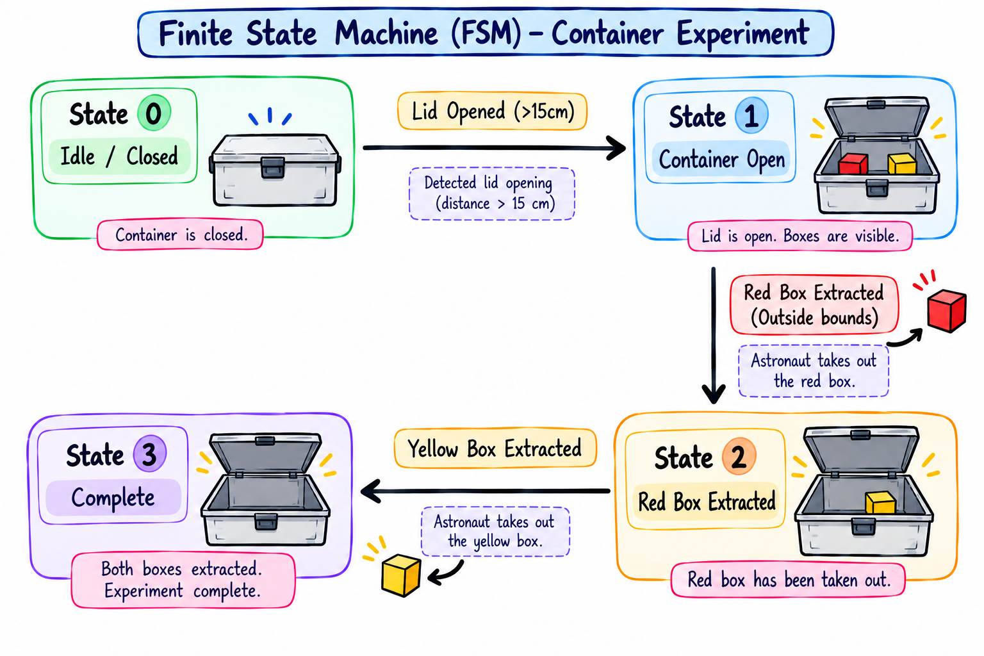

5.2 Transition Logic and Validation Rules
The state transition rules are modeled mathematically as a function of the detected spatial coordinates and hand-object interaction (HOI) states [cite: 132]:

- State 0 (Idle):
    - Somatic Prompt: "System initialized. Please open the primary container box." [cite: 132]
    - Transition Event: Container lid displacement $y_{lid}> 15 cm$ [cite: 132].
    - Target State: State 1.
- State 1 (Container Open):
    - Somatic Prompt: "Container opened. Next step: Please extract the red box." [cite: 132]
    - Transition Event: HOI contact validated on Red Box, followed by the Red Box coordinates migrating outside the container's 3D bounding box bounds [cite: 132].
    - Target State: State 2.
- State 2 (Red Box Extracted):
    - Somatic Prompt: "Red box extracted. Next step: Please extract the yellow box." [cite: 132]
    - Transition Event: HOI contact validated on Yellow Box, followed by the Yellow Box coordinates migrating outside the container bounds [cite: 132].
    - Target State: State 3 (Complete).
- State 3 (Complete):
    - Somatic Prompt: "Yellow box extracted. Experiment successfully complete." [cite: 132]

5.3 Anomaly and Sequence Deviation Gating
If the astronaut performs an action that violates the allowed transitions, the FSM halts sequence tracking, logs a warning state in the local database, and triggers an immediate voice alert [cite: 131, 132]:

A. Out-of-Order Interaction (State 1 $\to$ ERROR_SEQ)
- Trigger: Visual detection of the astronaut touching or extracting the yellow box while the FSM is actively awaiting red box extraction in State 1 [cite: 132].
- Voice Alert: "Warning: Procedural error. Red box must be extracted before yellow box." [cite: 132]

B. Sequence Skip (State 2 $\to$ ERROR_SKIP)
- Trigger: The astronaut re-closes the container lid ($y_{lid}le 15 cm$) or moves away from the rack while the yellow box remains unextracted [cite: 132].
- Voice Alert: "Warning: Step skipped. Please extract the yellow box to complete the sequence." [cite: 132]

To prevent temporary camera occlusions, edge noise, or lighting glitches from triggering false alerts, the state machine implements a temporal validation window [cite: 133]. A state transition or anomaly is only committed if the underlying spatial coordinate rules are violated consistently over 15 consecutive frames (0.5 seconds at 30 FPS), ensuring high operational reliability [cite: 133].

5.4 Edge Voice Synthesis (Offline Text-to-Speech)
To ensure complete independence from ground communication, voice alerts are synthesized locally using a quantized, edge-compatible Text-to-Speech (TTS) engine [cite: 132]. The engine uses a lightweight, neural-network-based speech synthesizer (such as a quantized Mel-spectrogram generator and vocoder) running on the Jetson Orin NX GPU, delivering high-fidelity, natural-sounding audio feedback with sub-100ms latency [cite: 132].

Chapter 6: Video Streaming, Local Storage, and Telemetry Logging

To comply with the strict telemetry and on-board data logging rules of the space station, the system splits its outputs into high-definition local storage, local IP video streaming, and lightweight text-based telemetry compression [cite: 121, 133].

+───────────────────────────────────────────────────────────────+
│ LOCAL RACK VIDEO CAPTURE │
+───────────────────────────────┬───────────────────────────────+
│
┌────────────────────────┼────────────────────────┐
▼ (NVENC Hardware H.264) ▼ (RTSP Streaming) ▼ (JSON Lines)
+──────────────+ +──────────────+ +──────────────+
│ On-Board SSD │ │ Specific IP │ │ 15 KB S-Band │
│ High-Res │ │ Tablet Term. │ │ Compressed │
│ Local Video │ │ Stream (LAN) │ │ Telemetry Log│
+──────────────+ +──────────────+ +──────────────+

6.1 Local Video Encoding & NVMe Storage
Raw video feeds from the fixed payload camera are processed and encoded in real time using the hardware-accelerated NVIDIA Encoder (NVENC) on the Jetson Orin NX [cite: 123]. The video is compressed to H.264 format at 1080p resolution and 30 frames per second, maintaining high-fidelity details of the experiment [cite: 123, 133]. The encoded files are stored locally on a high-endurance, space-qualified M.2 NVMe SSD mounted directly in the payload computer chassis [cite: 123, 133]. This preserves high-resolution records for physical recovery during future crew rotations [cite: 24, 133].

6.2 RTSP Live IP Streaming
While the raw video is stored locally, the NVENC-compressed stream is simultaneously cast over the space station's internal local area network (LAN) [cite: 133]. The system establishes a Real-Time Streaming Protocol (RTSP) server running locally on the edge computer, streaming the payload feed to a specific IP address [cite: 133]. Other crew members can monitor the experiment feed on portable tablets or secondary cabin terminals without impacting the primary AI processor's performance [cite: 133].

6.3 Lightweight JSON Lines Telemetry Compression (3,000,000:1 Ratio)
To bypass the strict bandwidth limits of transmitting data to ground teams, the edge engine translates the experiment's visual history into structured, timestamped JSON Lines (.jsonl) telemetry files [cite: 121, 122].

A 30-minute high-definition experiment video feed—which would occupy approximately 45 GB in uncompressed RAW format—is represented as a structured text telemetry file of under 15 KB [cite: 122, 166]. This represents an immense 3,000,000:1 data compression ratio, allowing ground controllers to monitor experimental success in real time despite extreme bandwidth limits [cite: 121, 122].

Example Empirical JSON Lines Output:
{"timestamp": "2028-10-24T09:15:02.001Z", "state": 0, "event": "system_init", "status": "SUCCESS", "message": "Awaiting container opening"}
{"timestamp": "2028-10-24T09:15:15.340Z", "state": 1, "event": "container_opened", "status": "SUCCESS", "message": "Suggesting next step: Extract red box"}
{"timestamp": "2028-10-24T09:15:30.120Z", "state": 1, "event": "yellow_box_touch", "status": "ANOMALY", "message": "Out of sequence detection: Yellow extracted before red"}
{"timestamp": "2028-10-24T09:15:31.450Z", "state": 1, "event": "voice_alert_triggered", "status": "ALERT_ACTIVE", "message": "Voice notification played"}

Chapter 7: Standalone Edge Compute and Radiation Hardening

Operating an artificial intelligence system inside an orbital spacecraft requires strict adherence to size, weight, power, and cost (SWaP-C) constraints [cite: 123].

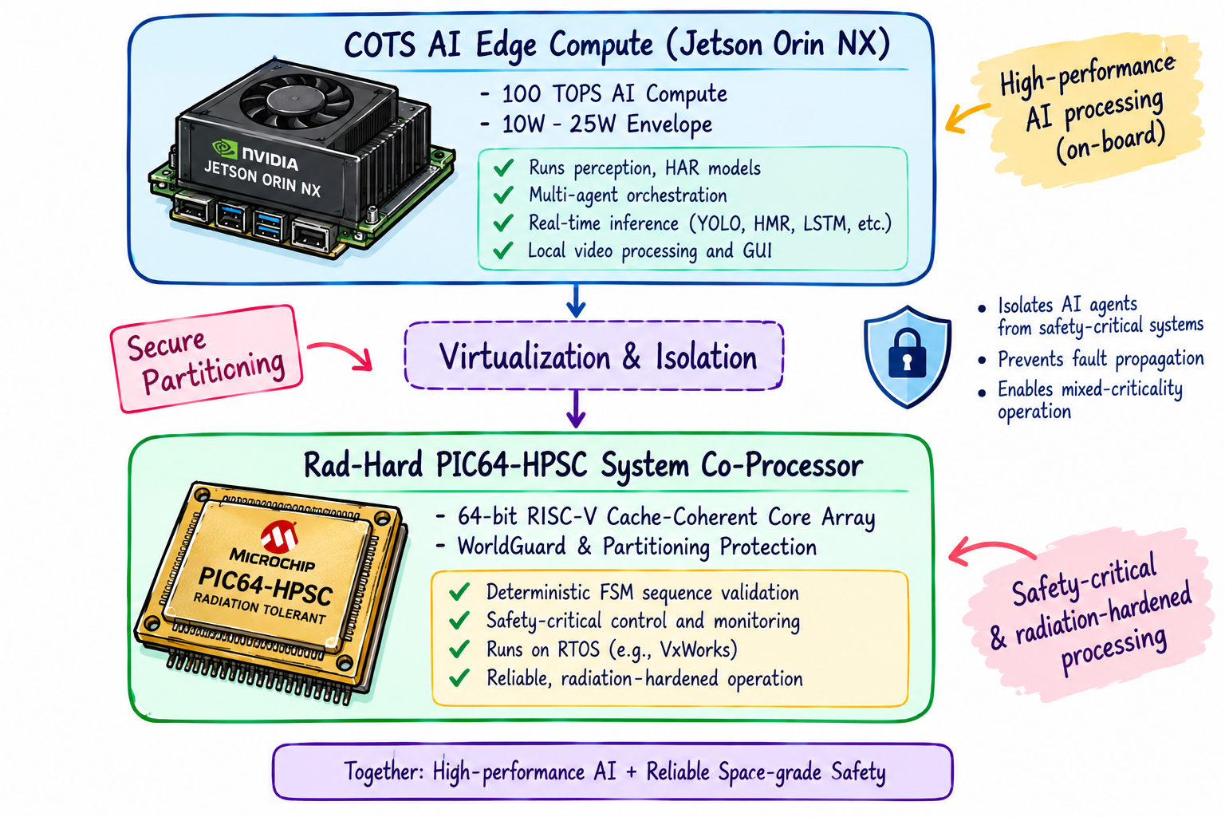

7.1 COTS GPU Edge Computing (NVIDIA Jetson Orin NX)
The primary computer vision and 3D HMR pipelines run on an NVIDIA Jetson Orin NX (16GB) System-on-Module (SoM) [cite: 70, 123].
- Performance: Delivers up to 100 TOPS of AI performance [cite: 70].
- Power Efficiency: The module scales its power consumption dynamically between 10W and 25W, fitting within the strict power budgets of BAS payload racks [cite: 70, 123].
- Thermal Dissipation: Because gravity-driven convective heat transfer is absent in space, the Jetson module is mounted on a customized aluminum conduction-cooling plate [cite: 123]. This plate directly transfers heat to the liquid cooling loop of the BAS laboratory rack, preventing thermal throttling during continuous inference [cite: 123].

7.2 Radiation Hardening and Space Qualification
Consumer-grade electronics are highly vulnerable to galactic cosmic rays (GCRs) and solar energetic particles (SEPs) in Low Earth Orbit, which cause single-event upsets (SEUs) and latch-ups [cite: 42, 123]. To ensure mission-critical reliability [cite: 122]:
- Shielding: The edge computing enclosure is lined with a high-hydrogen nanocomposite material and tantalum coatings (leveraging POEM-4 RSEM flight heritage) to absorb protons and heavy ions, reducing the ionizing radiation dose [cite: 113, 123].
- Watchdog Timers: A physical, radiation-hardened external watchdog timer continuously monitors the Jetson module [cite: 137]. If a single-event latch-up freezes the OS, the timer executes a hard power cycle within 50ms, resetting the system.

7.3 High-Performance Spaceflight Computing (PIC64-HPSC)
For core control and system monitoring, the edge platform integrates with the NASA/Microchip PIC64-HPSC system co-processor [cite: 151].
- Processor Architecture: The PIC64-HPSC features 64-bit cache-coherent RISC-V application cores augmented with 512-bit vector pipelines, delivering high-performance space-grade computing [cite: 151, 161].
- Fault Isolation: The PIC64-HPSC implements WorldGuard technology and hardware virtualization [cite: 151]. The deterministic validation FSM and system logging microservices are completely partitioned into a secure, fault-tolerant RTOS partition (e.g., VxWorks), while the visual perception networks run on a separate Linux partition. If the GPU pipeline crashes due to a software fault, the core state machine remains completely unaffected, maintaining continuous tracking and logging capabilities [cite: 151].

Chapter 8: Human-Machine Interfaces and Spaceflight Precursor Validation

8.1 Qt C++ Graphical User Interface (GUI)
To ensure ultra-low computational overhead on the on-board display terminals, the companion dashboard is developed in C++ using the native Qt framework [cite: 133, 135].

The GUI layout is organized into four main functional blocks [cite: 134, 135]:
- The Live Stream Panel: Displays the 1080p payload camera stream, overlaid with the reconstructed 3D skeletal mesh of the astronaut's arm and hands, as well as 3D bounding boxes tracking the experimental components [cite: 135].
- The Active Step Validator: Highlights the status of the experiment workflow, displaying a green checkmark for completed steps, a yellow indicator for the active task, and red flashing indicators during sequence errors [cite: 135].
- The Instruction Prompt: Displays a high-contrast text version of the active task or warning alert aligned with the voice alerts [cite: 135].
- System Diagnostics: Monitors edge board metrics, including CPU/GPU temperatures, memory load, storage health, and RTSP stream connection states [cite: 135].

+─────────────────────────────────────────────────────────────+
│ Qt C++ GUI MONITORING CONSOLE │
+─────────────────────────────────────────────────────────────+
│ [ LIVE STREAM PANEL ] [ ACTIVE STEP VALIDATOR ] │
│ • 1080p Video Feed • [OK] Step 1: Open Contain. │
│ • 3D Skeleton Overlay • [>>] Step 2: Extract Red │
│ • Bounding Boxes • [ ] Step 3: Extract Yellow│
│ │
│ [ DIAGNOSTICS PANEL ] [ INSTRUCTION PROMPT ] │
│ • Temp: 45°C • "Lid opened. Next step: │
│ • GPU load: 74% Please extract the red │
│ • RTSP Stream: ACTIVE box." │
+─────────────────────────────────────────────────────────────+

8.2 Flight Heritage and Precursor Validation (POEM-4)
Rather than launching directly to the BAS, ISRO utilizes the spent fourth stage of its PSLV rockets—repurposed as the PSLV Orbital Experiment Module (POEM)—as a cost-effective, in-orbit testing laboratory to earn "flight heritage" [cite: 23, 114].

The foundational technologies for this HAR system have already been successfully space-qualified on LEO precursor missions :
- On-Orbit AI Execution (MOI-TD): Launched in December 2024 aboard POEM-4 (during the PSLV-C60/SpaDeX mission) [cite: 7, 162], the Mission Operations Indicator–Technology Demonstrator (MOI-TD) payload (TakeMe2Space) acted as an on-orbit AI lab [cite: 168]. It successfully executed Machine Learning models uploaded from the ground and processed camera feeds in real-time, proving that edge-AI inference is fully viable on rocket stages in space [cite: 168].
- Vision-Based Robotic Servicing (RRM-TD): POEM-4 also hosted India's first space robotic arm (RRM-TD) developed by the ISRO Inertial Systems Unit (IISU) [cite: 8, 163]. This 7-degree-of-freedom manipulator successfully tested visual servoing, object motion prediction, and vision-based 6-DoF pose estimation in Low Earth Orbit [cite: 114, 163]. This flight-proven vision pipeline directly supports the spatial tracking logic used by your HAR payload [cite: 114].

Chapter 9: Conclusions and Spaceflight Roadmap

9.1 Summary of Contributions
This thesis has presented a robust, self-contained solution for validating scientific workflows on-board the Bharatiya Antariksh Station [cite: 120, 136]. By combining orientation-agnostic 3D Human Mesh Recovery with a deterministic state validation engine, the system operates reliably in microgravity without relying on continuous ground telemetry [cite: 136]. The custom synthetic data engine, paired with the PhysAstro-Pose semi-supervised learning framework, bridges the sim-to-real gap, ensuring high-integrity keypoint localization despite inverted postures, self-occlusions, and cluttered cabin backgrounds [cite: 124, 147, 178].

9.2 Future Implementation and Testing Roadmap
To transition this prototype into a flight-certified payload, the development roadmap follows a structured, three-phase testing pipeline:
- Phase 1: Terrestrial Drop Tower & Parabolic Flights (2026-2027): Ground testing of the visual models on drop towers and parabolic flight campaigns to verify coordinate projection stability during transient gravity fluctuations.
- Phase 2: LEO Precursor Validation (2027-2028): Deploying the visual tracking software on dedicated CubeSats or subsequent POEM stages to earn additional on-orbit runtime.
- Phase 3: Operational Integration on BAS (2028+): Mounting the cameras and conduction-cooled edge platforms directly inside the BAS-03 Science Research Module to guide astronauts hands-free through biotechnology and materials science experiments, documenting their outcomes with unmatched telemetry efficiency.

References
- On-Board Sequence Validation and Orientation-Agnostic Human Activity Recognition for Bharatiya Antariksh Station Payloads. [Markdown Source].
- On-board Human Activity Recognition and Computational Assistance for Microgravity Experiments on the Bharatiya Antariksh Station. [Markdown Source].
- Cui, Y.; Zhang, Z.; Chang, L. PhysAstro-Pose: Physics-Inspired Semi-Supervised Human Pose Estimation in Microgravity Environments. Sensors 2026, 26, 3406.
- Wen, D. et al. Go Beyond Earth: Understanding Human Actions and Scenes in Microgravity Environments. ICLR 2026 / arXiv:2506.02845.
- List of PSLV Orbital Experiment Module Flights. Wikipedia Source.
- Complete Solutions for PIC64-HPSC Spaceflight Computing Designs. Microchip Technology.
- Bharatiya Antariksha Station, Modules, Development, Significance. Vajiram & Ravi.
- Mandal, M. μBi-ConvLSTM: An Ultra-Lightweight Efficient Model for Human Activity Recognition on Resource Constrained Devices. arXiv 2026, 2602.06523.
- Cimon (robot). Wikipedia Source.
- AdaSpot: Spend Resolution Where It Matters for Precise Event Spotting. arXiv 2026, 2602.22073.

